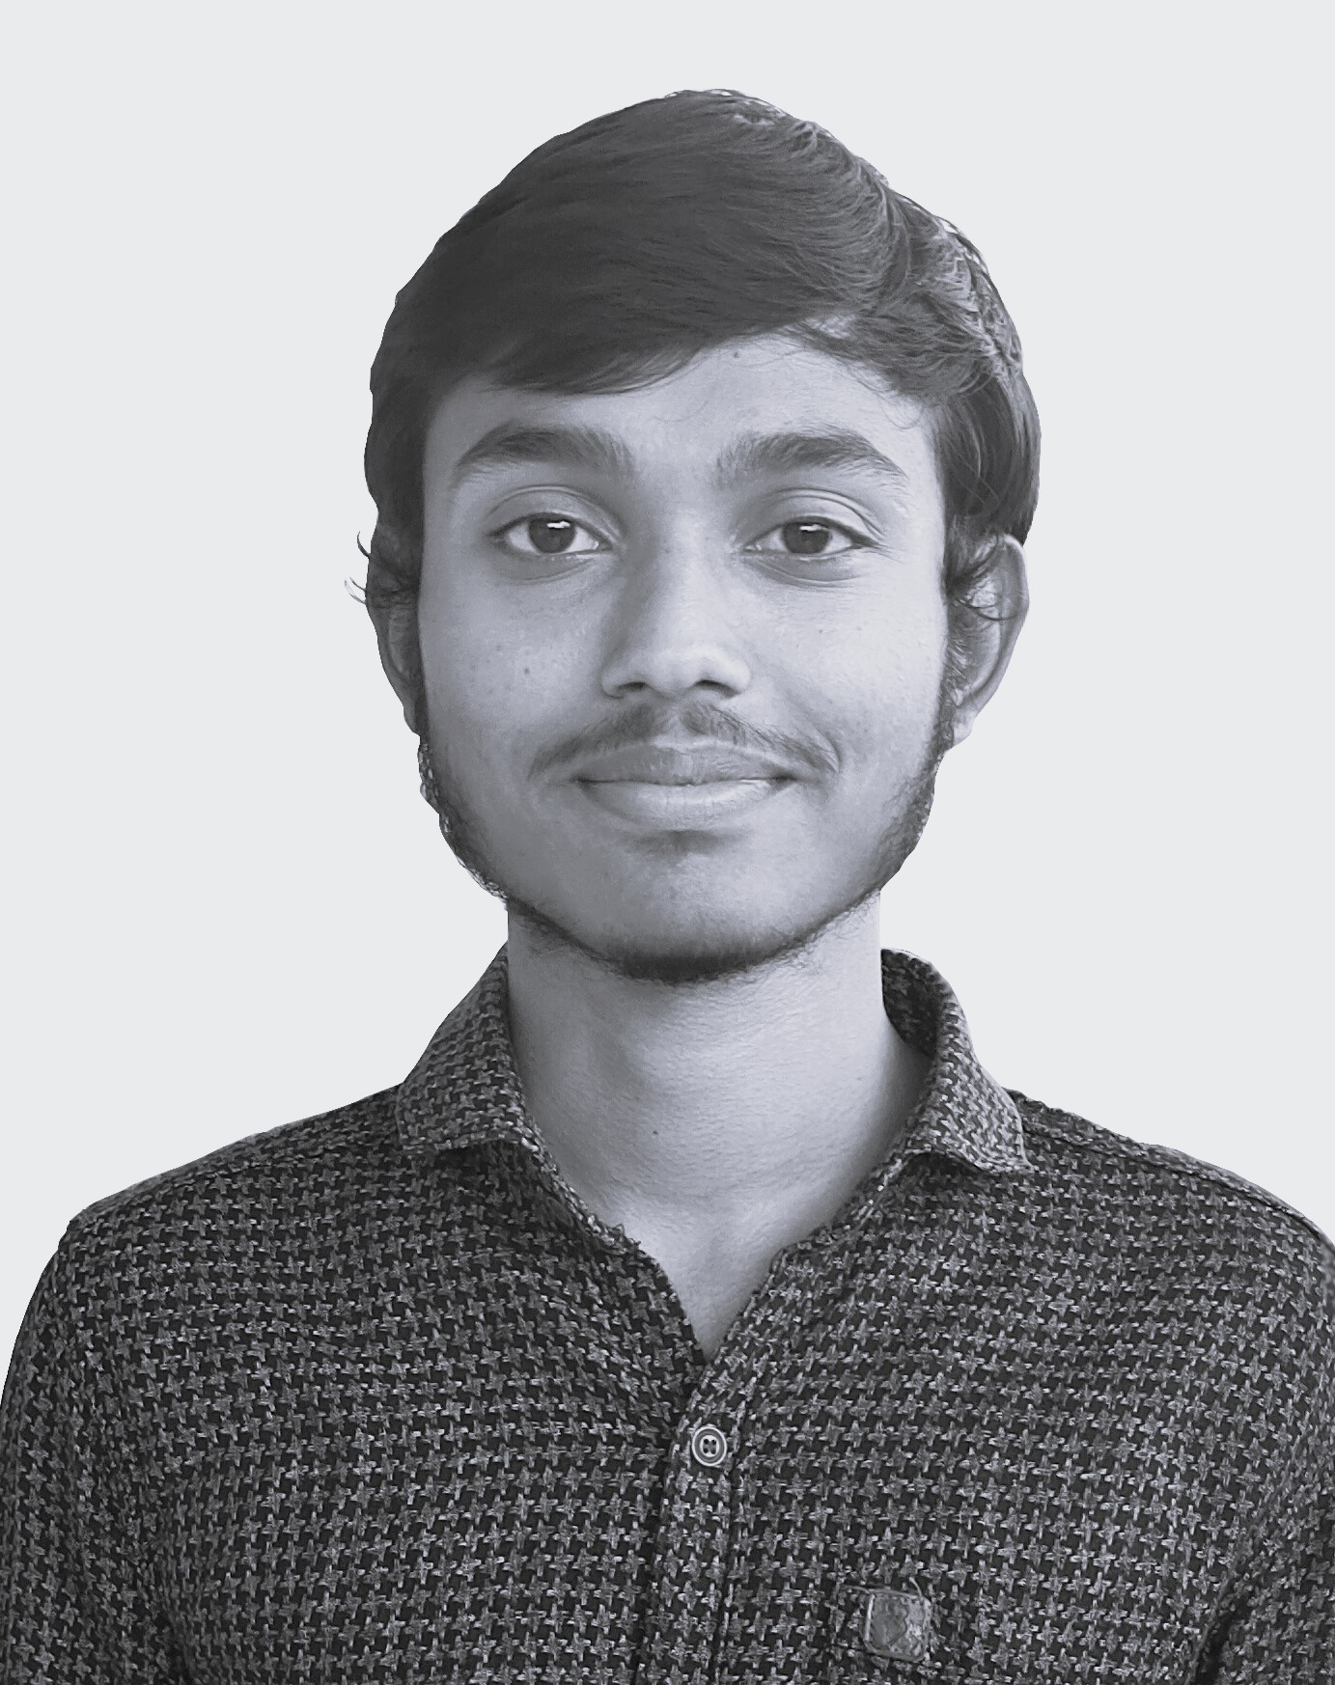

**Lekha Sathvik Devabathini**

+ 91 8331981309 |  [github.com/dlsathvik04](mailto:github.com/dlsathvik04) |  [in/dlsathvik04](mailto:in/dlsathvik04) |  [dlsathvik04@gmail.com](mailto:dlsathvik04@gmail.com)



 [dlsathvik04.github.io](https://dlsathvik04.github.io/#/) |  [Ongole, Prakasam, Andhra Pradesh, India.](https://maps.app.goo.gl/3XbmFUyHHAYcbA2A8)

**Profile**

Undergraduate student hardened in software development and coding with rigorous exposure to various challenging projects in the areas of Development, AI & ML, and Data Analytics. Proven ability to trigger progress in stagnant projects with useful observations and creative insights with consistent work.

**Education**

* Amrita School of Computing, Amritapuri: 2021 – Present (B. Tech with specialization in AI - 9.7/10 GPA)
* FIITJEE College, Vijayawada: 2019 – 2021 (11th and 12th – 95.6%)
* Jawahar Navodaya Vidyalaya, Ongole: 2014 – 2019 (6th to 10th - 94%)

**Internships**

* **Intern at Amrita Centre for Wireless Networks and Applications (Oct 2022 – Present):**
  + Research on applications of Artificial Intelligence in Vehicular Networks.

▪ Machine Learning using Scikit-Learn. ▪ Deep Learning using TensorFlow.

* + Full Stack and Android development for a finance application with scalability in mind.

▪ Android UI and UX design using flutter ▪ API development using Express.js in Node.js

▪ Database Management using MySQL, PostgreSQL, and MongoDB.

* **Member at ACM-AI@Amrita (Apr 2022 – Feb 2023)**
  + Workshops, Presentations, and club activities.

▪ Machine Learning ▪ Deep Learning ▪ Federated-Learning

**Projects**

* [**AmPulse: Dec 2023** ](https://github.com/dlsathvik04/Auth)

Amrita exclusive social media apllication built to bridge the gaps beween students of different batches. Bult a good foundation and community for sustainable development.

**Tech Stack:** Node.js, Express.js, React, MySQL

* [**AmritaSREE: Aug 2023** ](https://github.com/dlsathvik04/Auth)

Full-Stack module built using Express and Flutter with basic authentication features as a part of software solution for women SHG’s which is to be scaled to lakhs of users.

**Tech Stack:** Node.js, Express.js, Flutter

* [**Device Control: Aug 2023** ](https://github.com/dlsathvik04/DeviceControl)

Application for real-time control of devices. Achieved near real-time control among multiple clients using Socket Programming. Explored the concepts of Multi-threading and Synchronization.

**Tech Stack:** Java, Flutter, Dart, Sockets

* [**Dyslexia Detection using Machine Learning: Aug 2022** ](https://github.com/dlsathvik04/Dyslexia_Detection)

A prototype based on Machine Learning which uses handwriting samples of children to predict presence of dyslexia. Achieved 95% accuracy on the available data. Won Smart India Hackathon for the year 2022.

**Tech Stack:** Python, Scikit-Learn, Streamlit

**Skills**

Full-Stack Development, Mobile App Development, Machine Learning, Deep Learning, Research.

* **Programming Languages:** ▪ Java ▪ Python ▪ JS/TS | HTML | CSS ▪Dart
* **Frameworks:** ▪ Express.js ▪ Flutter ▪ Scikit-Learn ▪ TensorFlow ▪ Spring ▪ Django ▪ React
* **Tools:** ▪ SQL ▪ Git ▪ Firebase ▪ Bash ▪ PowerShell ▪ Linux
* **Soft skills:** ▪ Project Organisation ▪ Technical Writing ▪ Presentation

**Certifications**

* freeCodeCamp - Back End Development and APIs (300 h)
* freeCodeCamp - JavaScript Algorithms and Data Structures (300h)
* Master Express Framework
* Data Science with Python (UIITG-220309592)

**Achievements**

* **Winners- Smart India Hackathon 2022** ([Certificate](https://raw.githubusercontent.com/dlsathvik04/dlsathvik04/main/certifications/SIH2022.jpeg)): Prototyped a machine learning based solution for detection of Dyslexia in children which uses various libraries cloud APIs.